CALL FOR ABSTRACTS: Scottish Paediatric Anaesthetic Network 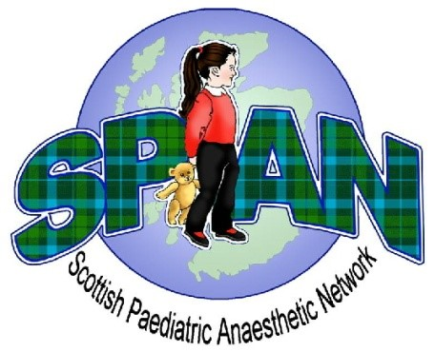

We are delighted to announce that the Scottish Paediatric Anaesthetic Network Spring Meeting will be held on 17th March 2023.

Submissions for poster presentation’s relating to Paediatric Anaesthesia are now welcome. The committee will review and the top three posters will be selected for oral presentation.

1st Prize oral presentation £100
1st Prize poster presentation £50

Please submit your poster abstract spantraineerep@gmail.com in a word document with a word count of less than 400 words by Friday 24th February 2023.

This is an excellent opportunity for trainees with an interest in Paediatric Anaesthesia to present work at a national and friendly meeting.

Look forward to seeing as many of you there as possible,

Regards,

Span Trainee Rep

