Bristol Ultrasound Vascular Access Course (BUS-VAC)

Dates: Friday 2nd June 2023
Time: 1300 to 1600
Location: Department of Anaesthesia
Bristol Royal Infirmary

Supported by

MEDDLE courses welcome candidates in all medical and nursing backgrounds from any region in the UK.
The course provides high-quality teaching and hands-on experience with ultrasound and cannulation.
Open to all skill levels. Our team welcomes all levels of prior ultrasound experience.
Scan or email to sign up for a course or visit: meddlecourses.co.uk.
Email: meddleuscourses@gmail.com
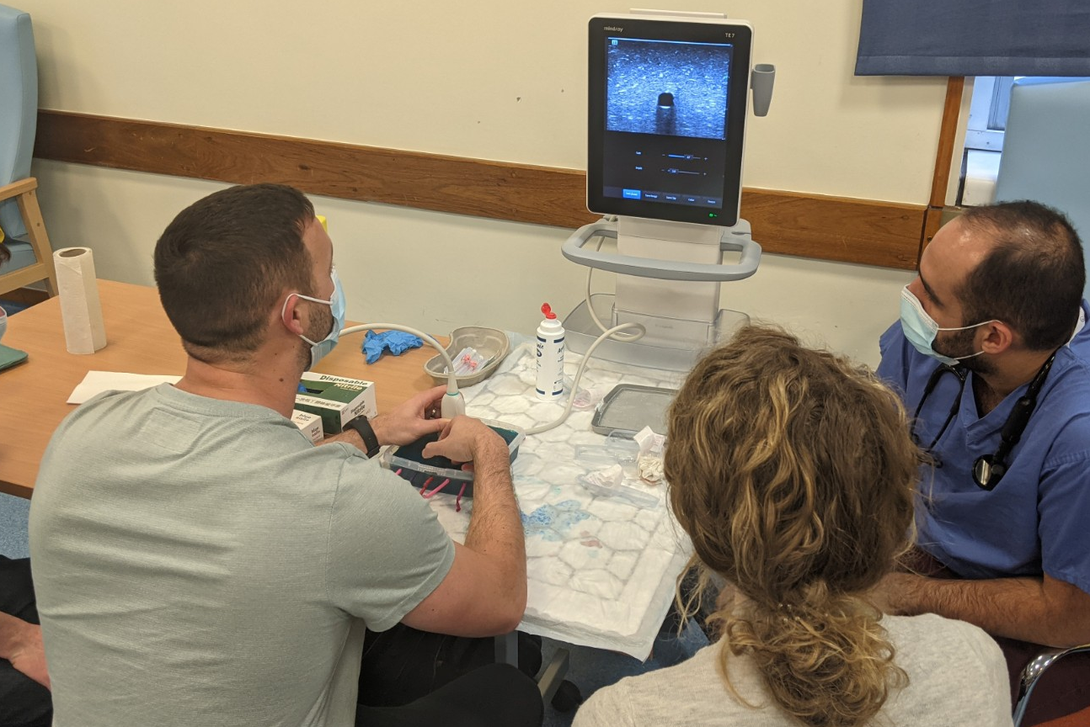
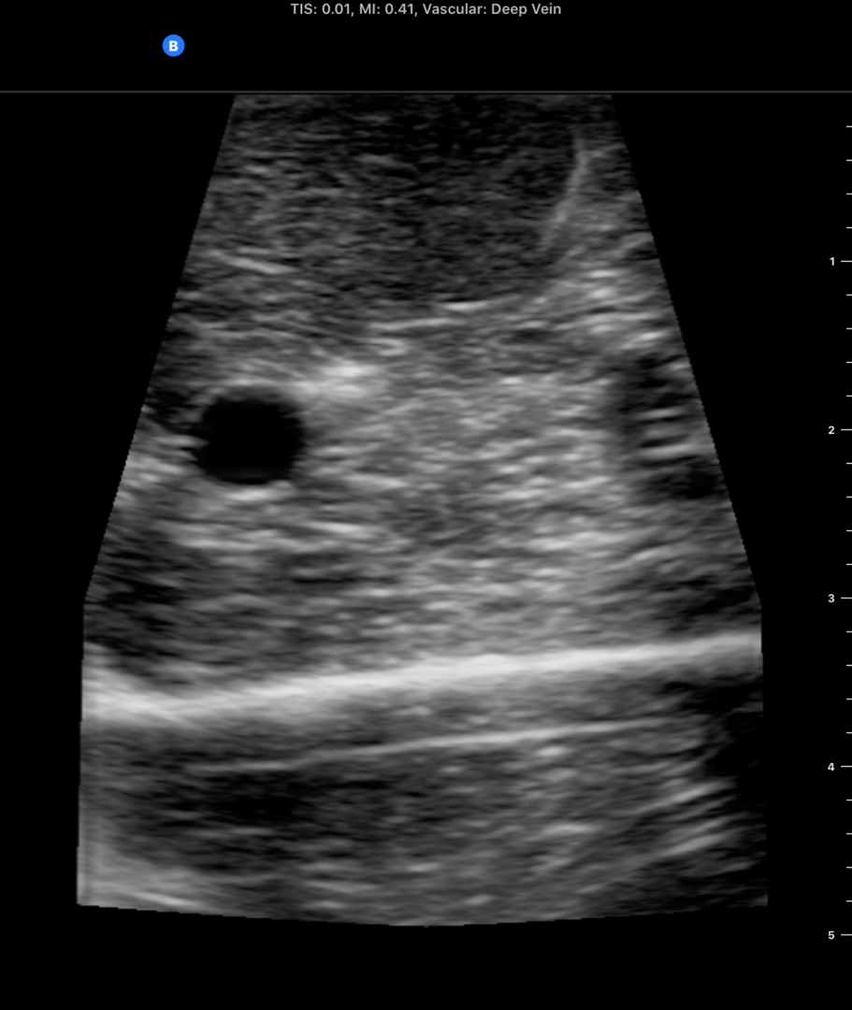

- Ultrasound guided peripheral cannulation
- High-quality devices and mannequins
- Open to all skill levels
- Lots of hands-on practical experience
- Half day course, 0900-1200 OR 1300-1600
- £50 per person
- Gain a new skill and confidence in cannulation of difficult patients!

