Dear Delegate,
Thank you for registering for the SETSA Spring Meeting 2025, hosted by the South East Thames Society for Anaesthetists and Guy’s and St Thomas’ Hospital
This year’s Spring Meeting offers a fantastic day of cutting-edge talks and interactive workshops, all designed to support your professional development and attendees will receive 6 CPD points.
📅 Friday 9th May 2025
📍 Strand Campus, King’s College London, WC2R 2LS - see details below
🕗 Registration from 08:15 | Programme begins at 09:00

❗ Key Programme Highlights:
- Keynote Address: In Good Practice – Prof Colin Melville, GMC
- Expert talks including GLP-1 agonists,airway safety utilising digital technology, TIVA models and advances and implications of AI and digital technology in anaesthesia…
- Afternoon workshops to provide small group learning in a wide range of topics
  - Sign-up to your preferred workshop at registration in the morning, workshop details available in attachment and on website. First come first served.
❓Q+A Panel discussion
- QR link available to enter questions for all speakers during the panel discussion.
☕ Coffee breaks, lunch, and refreshments provided
📲 Share your experience: @qeqmSETSA
We look forward to a fantastic day
Warm regards,
SETSA 2025 Organising Committee
Dr Gunjeet Dua | Dr Mary Madden | Dr Emma Bryson | Dr Tariq Ali | Dr Chris Holt | Dr Jules Harrington
📧 For queries: setsa2025@gmail.com

SETSA SPRING MEETING 2025 LOCATION:
The conference is to be held at KCL Strand campus. Please visit this website to help plan your journey https://www.kcl.ac.uk/visit/strand-campus. Upon arrival at the KCL campus (to the left wing of Somerset house - see pictures below) you will enter a security gated foyer where there will be faculty to meet you and you will receive access into the building.
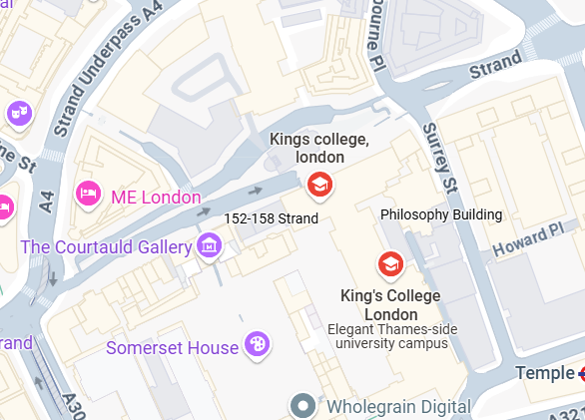

KING’S COLLEGE
LONDON
- STRAND CAMPUS
Postcode WC2R 2L

https://www.google.co.uk/maps/search/wc2r+2ls+king's+college/@51.5117002,-0.1188751,17z/data=!3m1!4b1?entry=ttu&g_ep=EgoyMDI1MDQyOS4wIKXMDSoASAFQAw%3D%3D
