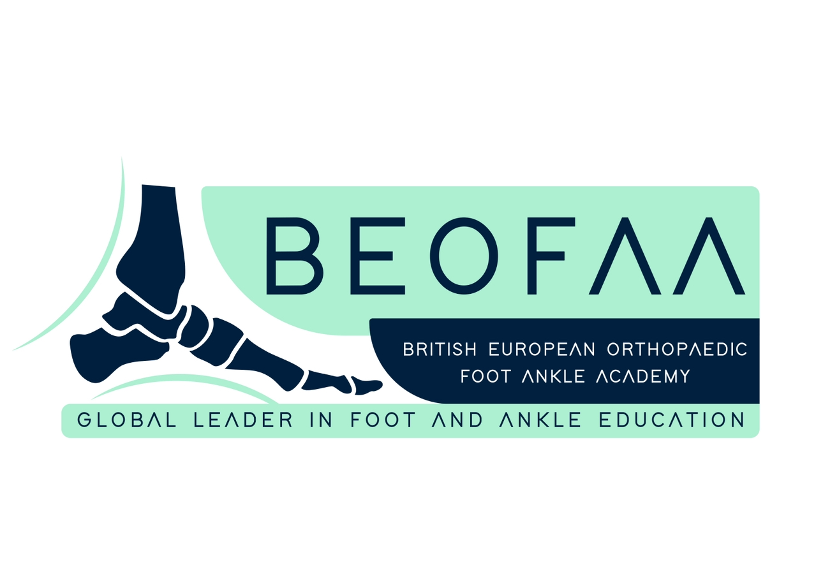

2nd BEOFAA Foot & Ankle Symposium
British European Orthopaedic Foot & Ankle Academy (BEOFAA)
Radisson Blu Hotel, Istanbul, Sisli
Istanbul, Turkey, 23rd & 24th October 2026


Forum Overview
The 2nd BEOFAA Foot & Ankle Symposium is a high-level, case-driven educational meeting designed for current and alumni BEOFAA fellows, focusing on complex decision-making, advanced surgical strategies, and interactive peer learning.

Faculty
Prof Maneesh Bhatia (Course Director, Leicester, UK)
Manuel Monteagudo (Course Director, Madrid, Spain)
Mark Davies (Sheffield, UK)
Nick Cullen (Stanmore, UK)
Norman Espinosa (Zurich, Switzerland)
Tim Clough (Wrightington, UK)
Lucky Jeyaseelan (London, UK)
Yasser Aljabi (Dublin, Ireland)
Bedri Karaismailoglu (Istanbul, Turkey)

Day 1 – Friday, 23 October 2026

Theme: Complex Ankle, Hindfoot & Midfoot Deformity Correction

08:00-08:50 Registration & Coffee
8:50-09:00 Welcome
09:00–09:15 Assessment of complex deformity around ankle and foot – Mark Davies

09:15–09:30 Calcaneal osteotomy: surgical technique – Maneesh Bhatia

09:30–09:45 Cotton and Evans osteotomy: surgical technique – Manuel Monteagudo

09:45-10:00 Arthrodesis versus arthroplasty in the presence of deformity – Tim Clough

10:00–10:30 Panel discussion & Q&A

10:30–11:00 Tea / Coffee break + networking

11:00–12:30 Case based discussions – All Fellows & Faculty (90 minutes)

12:30–13:30 Lunch + networking

13:30–13:50 Supramalleolar osteotomies: surgical technique – Norman Espinosa

13:50–14:10 Tibialis posterior tendon transfer, Jones procedure, wedge resection & midfoot fusion – Nick Cullen

14:10–14:30 Hindfoot fusion in complex deformity correction – Mark Davies

14:30–15:00 Panel discussion & Q&A

15:00–15:30 Tea / Coffee break + networking

15:30–16:00 3-D Technologies and Patient -Specific Guides in Foot and Ankle Surgery: From Scan to Scalpel - Bedri Karaismailoglu

16:00–17:00 Book launch (Surgical techniques of the Foot and Ankle & Key note lectures from the authors

Day 2 – Saturday, 24 October 2026

Theme: Foot & Ankle Trauma, Hands on workshop, Sports injuries

09:00–09:30 Complex Ankle fractures: Lucky Jeyaseelan

09:30–10:00 How to manage post traumatic arthritis of Ankle: Yaseer Aljabi

10–10:30 Panel discussion & Q&A

10:30–11:00 Tea / Coffee break

11:00–12:30 Hands on practice workshop for Fellows: All faculty ( 90 minutes)

12:30–13:30 Lunch

13:30–13:50 Sports injuries in athletes: Manuel Monteagudo

13:50–14:10 Surgical management of ankle cartilage injuries: Nick Cullen

14:10–14:30 Panel discussion & Q&A

14:30–14:45 Forum summary, certificates & close

