**Dear Delegate,**

Thank you for registering for the **SETSA Spring Meeting 2025**, hosted by the **South East Thames Society for Anaesthetists** and **Guy’s and St Thomas’ Hospital**

This year’s Spring Meeting offers a fantastic day of **cutting-edge talks** and **interactive workshops**, all designed to support your professional development and attendees will receive **6 CPD points**.

📅 **Friday 9th May 2025**📍 **Strand Campus, King’s College London, WC2R 2LS - see details below**🕗 **Registration from 08:15 | Programme begins at 09:00**

### **❗ Key Programme Highlights:**

* **Keynote Address**: *In Good Practice* – Prof Colin Melville, GMC
* Expert talks including GLP-1 agonists,airway safety utilising digital technology, TIVA models and advances and implications of AI and digital technology in anaesthesia…
* Afternoon **workshops** to provide small group learning in a wide range of topics
  + Sign-up to your preferred workshop at registration in the morning, workshop details available in attachment and on website. First come first served.

❓**Q+A Panel discussion**

* QR link available to enter questions for all speakers during the panel discussion.

☕ **Coffee breaks, lunch, and refreshments provided**

📲 **Share your experience:** [@qeqmSETSA](https://twitter.com/qeqmSETSA)

We look forward to a fantastic day

Warm regards,

**SETSA 2025 Organising Committee***Dr Gunjeet Dua | Dr Mary Madden | Dr Emma Bryson | Dr Tariq Ali | Dr Chris Holt | Dr Jules Harrington*

📧 For queries: **setsa2025@gmail.com**

**SETSA SPRING MEETING 2025 LOCATION:**

The conference is to be held at KCL Strand campus. Please visit this website to help plan your journey <https://www.kcl.ac.uk/visit/strand-campus>. Upon arrival at the KCL campus (to the left wing of Somerset house - see pictures below) you will enter a security gated foyer where there will be faculty to meet you and you will receive access into the building.

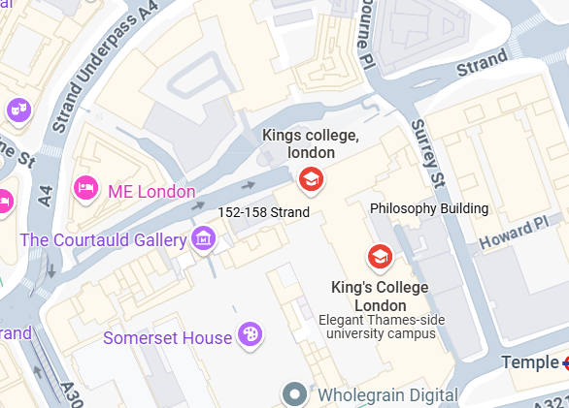

**KING’S COLLEGE**

**LONDON**

* **STRAND CAMPUS**

Postcode WC2R 2L

<https://www.google.co.uk/maps/search/wc2r+2ls+king's+college/@51.5117002,-0.1188751,17z/data=!3m1!4b1?entry=ttu&g_ep=EgoyMDI1MDQyOS4wIKXMDSoASAFQAw%3D%3D>

