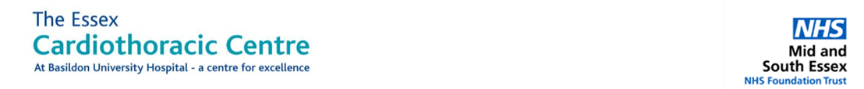
fTOE course
Essex CTC, Basildon
12TH February 2026
8:45-9:00 | Registration and Introduction
9:00-9:20 | Indications, Contra-indications and risks of TOE | Dr Ahmed Eldesoky
9:20-9:45 | Basic Physics and Image optimization | Dr Chandra Joshi
9:45-10:15 | Basic fTOE views | Dr Alisha
10:15-10:30 | Coffee break
10:30-11:00 | LV and RV assessment | Dr Ragu Nalgirkar
11:00-11:45 | Valvular pathology | Dr Maria Maccaroni
11:45-12:15 | Pericardial diseases, LAA thrombus, PFO, Aortic disease | Dr Sali Urovi
12:15- 13:00 | LUNCH
13:00-14:00 | Hands on Simulator Basic- Group A | Faculty
14:00-15:00 | Hands on Simulator Advanced – Group B | Faculty
15:00-16:00 | Image interpretation and post-processing on Philips Workstations- Group C | Medical Representative/Faculty
16:00-16:15 | Coffee break
16:15-16:50 | Training requirements / Quiz | Dr Tamer Montaser
16:50-17:00 | Closing remarks

