### **Point-of-Care Ultrasound (POCUS) Training Day**

**27th March 2026**

**Hosted: Faculty from Essex Cardiothoracic Centre at Basildon Hospital**

**Location: SIM Suite Basildon Hospital**

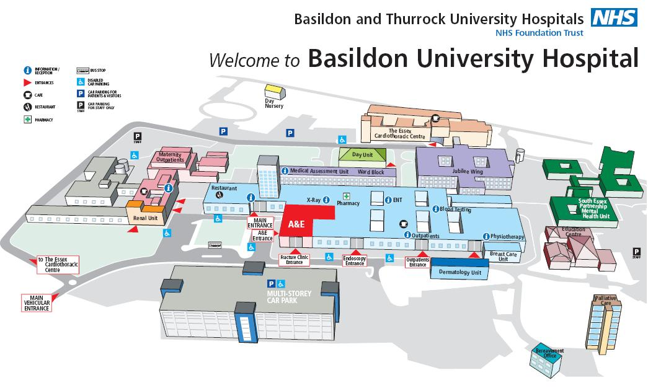

**Course Fee - £100**

**This full-day, hands-on course provides a comprehensive introduction to point-of-care ultrasound (POCUS) with a focus on emergency and critical care applications. Designed for healthcare professionals seeking practical ultrasound skills, the program blends foundational theory with real-time scanning practice under expert guidance.**

**Topics cover, core principles of ultrasound physics, image optimisation, and machine operation. Clinical applications, bedside cardiac ultrasound for shock and cardiac arrest, lung ultrasound for conditions such as pneumothorax and pulmonary oedema, and the use of ultrasound in trauma through the eFAST examination.**

**There is a focus on ultrasound-guided procedures, including central venous access, thoracentesis, paracentesis, and peripheral nerve blocks, equipping participants with essential procedural skills applicable in high-acuity settings.**

Course Programme: Application of Ultrasound in Emergency Settings

Comprehensive One-Day Training Itinerary

* 08:30 – 09:00 | Registration & Welcome Refreshments

Participant sign-in and informal networking

* 09:00 – 09:15 | Opening Remarks & Course Objectives

Introduction of faculty and a comprehensive overview of the day’s agenda

* 09:15 – 10:00 | Session 1: Fundamentals of Ultrasound Physics and

Machine Operation

Core principles: the properties of sound waves, probe selection, and image optimisation

Introduction to machine controls and practical demonstration of device settings – **Lecturer: Dr Sali Urovi**

### **Fundamentals of Ultrasound Physics and Machine Operation**

* 10:00 – 10:45 | Session 2: Cardiac Ultrasound in the Emergency

Department

Rapid bedside echocardiography for shock, cardiac arrest, and pericardial effusion

Guided hands-on practice with standard cardiac imaging

Windows - **Lecturer: Dr Maria Rita Maccaroni**

### **Cardiac Ultrasound in the Emergency Department**

* 10:45 – 11:00 | Morning Refreshment Break

Light refreshments and the opportunity for informal interaction with faculty

* 11:00 – 11:45 | Session 3: Lung Ultrasound

Diagnostic approach for pneumothorax, pleural effusion, and pulmonary oedema.

Interactive case studies and participant scanning sessions - **Lecturer: Dr Tamer Montaser**

### **Lung Ultrasound**

* 11:45 – 12:45 | Session 4: Ultrasound in Trauma (eFAST Examination)

Clinical indications for emergency ultrasound in trauma

scenarios

Detailed review of the eFAST exam: focused assessment with sonography for trauma patients

Live demonstration accompanied by supervised group

Practice - **Lecturer: Dr Maria Rita Maccaroni & Tamer Montaser**

### **Ultrasound in Trauma (eFAST Examination)**

* 12:45 – 13:45 | Lunch Break
* 13:45 – 14:30 | Session 5: Ultrasound-Guided Procedures

Indications and techniques for central venous catheter insertion, thoracentesis, paracentesis, and peripheral nerve blocks - **Lecturer: Dr Sali Urovi**

### **Ultrasound-Guided Procedures**

* 15:15 – 15:30 | Afternoon Break
* 15:30 – 16:30 | Session 6: Case-Based Scenarios & Hands-On Skills Laboratory

Individual skills assessment with personalised faculty feedback

* 16:30 – 16:45 | Summary, Questions & Answers, and Certificate Presentation

Key summary points, further resources for continued learning

Distribution of certificates of completion to all participants

# Additional Information

* All practical components are delivered under direct supervision, with access to live models.
* Participants are encouraged to contribute clinical scenarios from their own practice for group discussion.
* Comprehensive course materials and reference guides will be provided electronically.
* Support personnel will be available throughout the duration of the course for any assistance required.