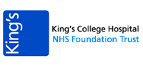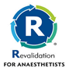
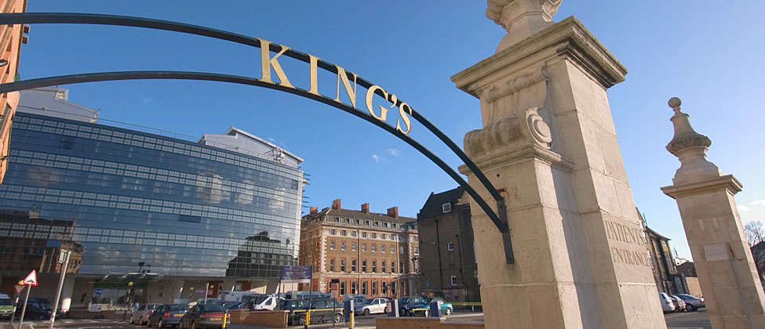

38th King’s College Hospital Advanced Airway Management Workshop
Date: Friday 3rd October 2025
Venue: Weston Education Centre, King’s College Hospital,
Denmark Hill, London, UK SE5 9RS
Programme

Practical Hands on Experience
09:00 - 10:00 Registration and coffee | 10:00 - 12:30 Morning session (5 stations)
12:30 - 13:30 Lunch | 13:30 - 16:30Afternoon session (6 stations)

- Nasal and Oral Fibreoptic intubation  - Videolaryngoscopy  - Hybrid Intubation Techniques  - ORSIM Simulated airway trainer  - Rescue intubation via SAD  - Airway & Gastric Ultrasound &HFNO | - Staged extubation  - Front of neck access  - Human factors airway simulation  - Lung Isolation techniques  - Paediatric airway management
Places: Strictly limited to 50 (early booking advised)
CPD Accreditation: 6 CPD external credits by RCoA,
Course fee: £175 (Subsidised fee for South Thames Trainees £125)
For Course booking: BookCPD.com
Breakfast and lunch will be provided
Course Administrator: Ms Jackie Barnett: jacqueline.barnett1@nhs.net
Phone: 0203 299 5971
Course Chair: Dr Jay Dasan
Course Directors: Dr Bran Retnasingham

