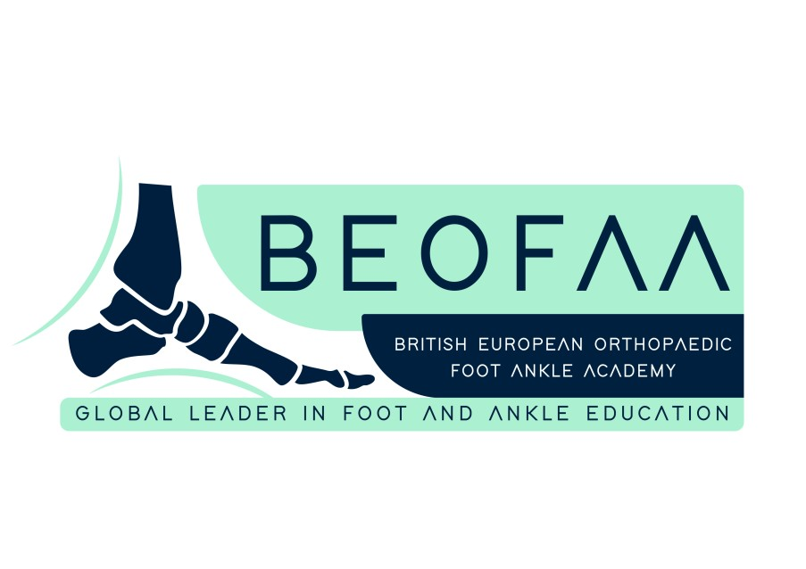

**5th BRITISH EUROPEAN ORTHOPAEDIC FOOT AND ANKLE FELLOWSHIP**

*Programme – 01/09/25 to 25/11//25*

# WELCOME

01/09/25 (Monday): Welcome to the BEOFAA Online Fellowship - Maneesh Bhatia – Manuel Monteagudo

*Introduction from the BEOFAA directors to welcome all the fellows and introduction to the faculty*

# FOREFOOT

02/09/25 (Tuesday): Great toe issues (Bunion & Arthritis) - How to fix? – Maneesh Bhatia

*All the issues related to hallux including a range of treatment options tailored to the individual patient*

04/09/25 (Thursday): Visual gait analysis & pathophysiology of forefoot disorders – Manuel Monteagudo

*A masterclass on clinical assessment & biomechanics of the foot*

09/09/25 (Tuesday) : Lesser toe issues– Robert Clayton (Chair Maneesh Bhatia)

*Lesser toes but not lesser problems! A talk that will help to improve your understanding regarding complexity of forefoot disorders*

11/09/25 (Thursday): Case/s of the week plus Tips and Tricks with Manuel Monteagudo *Practical case-based approach to interesting forefoot problems*

16/09/25 (Tuesday): Great toe issues: A different perspective – Tim Clough (Chair Maneesh Bhatia)

*Pearls of wisdom from an expert that you will not find in your books*

18/09/25 (Thursday): Why does forefoot surgery fail? – Nikos Gougoulias (Chair Manuel Monteagudo)

*An in-depth analysis of failures & tips for revision*

# MIDFOOT/HINDFOOT

23/09/25 (Tuesday): Case/s of the week plus Tips & Tricks with Manuel Monteagudo

*Listen from the expert- Case based discussions and practical solutions to meet real life difficult clinic and operating room challenge*

25/09/25 (Thursday): Pes plano valgus deformity– Maneesh Bhatia

*Tibialis Posterior dysfunction/ Spring ligament/ Progressive collapsing flat foot? – A lecture that looks at the current controversies and an attempt for simplification of the complex dynamics*

30/09/25 (Tuesday): Cavovarus deformity – Karan Malhotra (Chair Maneesh Bhatia) *Everything you need to know from pathogenesis to surgical strategies*

02/10/25 (Thursday): Arthrodesis midfoot and hindfoot– Manuel Monteagudo

*Indications/ Techniques/ Implant selection/ Outcome following fusion of midfoot/hindfoot* **ANKLE**

14/10/25 (Tuesday): Ankle fusion surgery – Maneesh Bhatia

*How does ankle arthrodesis affect gait & function? Arthroscopic versus open techniques*

16/10/25 (Thursday): Ankle arthroplasty – Yasser Aljabi (Chair Manuel Monteagudo)

*Indications/ Contraindications/ Learning curve of the surgeon and patient selection*

21/10/25 (Tuesday) : Case/s of the week plus Tips and Tricks – Maneesh Bhatia *Interesting cases/s and sharing the experience for complex ankle problems*

23/10/25 (Thursday): Joint preservation in ankle arthritis – Norman Espinosa (Chair Manuel Monteagudo)

*Limits of deformity, surgical planning and surgical techniques to address ankle arthritis – Alternative option to fusion and replacement*

# DIABETES/ TRAUMA/ SPORTS

28/10/25 (Tuesday): Talus/Calcaneal fractures – Stefan Rammelt (Chair Manuel Monteagudo)

*Complex trauma made simple: Pearls of wisdom*

30/10/25 (Thursday): Charcot Arthropathy – Guest lecture (Chair Maneesh Bhatia)

*How to deal with deformity arising due to diabetic (neuropathic) foot? Expert guidance to help you deal with complex scenarios*

04/11/25 (Tuesday): Case/s of the week plus Tips & Tricks Trauma & Sports with Maneesh Bhatia

*Practical case-based approach to demanding sport trauma scenarios*

06/11/25 (Thursday): Ankle instability and Peroneal tendon disorders – Jesús Vilá y Rico (Chair Manuel Monteagudo)

*How and when to operate the peroneal tendon and ankle instability? Arthroscopic versus open approach? How to avoid complications?*

11/11/25 (Tuesday): Ankle Fractures – Hiro Tanaka (Chair Maneesh Bhatia)

*Indications/ approaches/Trimalleolar fractures/ Ankle fractures in diabetics and elderly*

13/11/25 (Thursday): Achilles tendinopathy and rupture – Manuel Monteagudo

*How and when to operate Achilles tendinopathy and rupture? Timing of surgery. Approach and technique? How to avoid complications? When to weight bear? Post-op rehabilitation*

18/11/25 (Tuesday) Ankle cartilage defects – Nick Cullen (Chair Manuel Monteagudo)

*Role of bone marrow stimulation and chondrogenesis techniques/ Arthroscopic versus open approach*

20/11/25 (Thursday) : Dealing with large talar defect – Hindfoot reconstruction techniques – Mark Davies (Chair Maneesh Bhatia)

*Autograft/ Allograft/ 3D reconstruction/ Nail versus plate*

25/11/25: Fellow’s Day (Case presentations by fellows)/ Best Fellow Award and Farewell - Maneesh Bhatia and Manuel Monteagudo

*Last but not least Fellows to present selected cases, Two Best Fellow award presentation and Farewell to all fellows -Goodbye but stay in touch!*

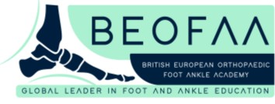

**Please register using either QR codes on the next page**