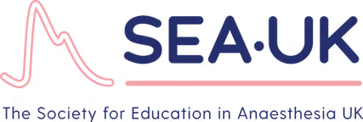
SEA-UK ASM
20th April 2026
The Bristol Hotel, Harbourside.
Registration Open

Evolving Paradigms in Anaesthesia: "Emerging trends in training and expanding role of the anaesthetist"

08:30 | Registration Opens
09:00 | Introduction and Welcome to SEA-UK 2026  Dr. Amit Ranjan / President SEA UK / SEA UK committee
Session1 | The Expanding Role of the Anaesthetist
09:15 | PHEM  Dr. Tom Rennison
09:40 | Anaesthesia in the developing world  Dr. Chris Walker
10:05 | Frailty / POPS  Dr. David Shipway
10:30 | Sustainability in Anaesthesia  Dr. John Hickmann
10:55 | Coffee Break & Posters
Session2 | Women in Anaesthesia
11:15 | Chair – Dr Fiona Donald  - Equity of Training Opportunities in Regional Anaesthesia – Dr Annabel Pearson  - Women’s Health and Training – Dr Lucinda Whitton  - Breaking Down Barriers in Trauma Anaesthesia – Dr Nirosha DeZoysa
12:15 | Lunch Break & Posters  AGM 12:15-12:30
Session3 | Innovation in Education  Chair -
13:15 | Simulation  Dr. Junaid Fukuta
13:40 | Augmented Reality in Regional Anaesthesia  Dr. Arul James
14:05 | Debate: Does ChatGPT have a place in anaesthetic training & education.  Dr. Ed Miles vs Dr. Matt Aldridge
14:40 | Coffee Break & Posters
Session 4 | Training and Research
15:00 | Key note/ Plenary Session – A Career in Education  Dr. Mike O’Connor
15:25 | Training in Research  Dr. Ned Gilbert-Kawai
15:50 | Free Paper Session – Chair
16:25 | Top Papers  Swati Gupta and Tom Baumer
16:40 | Prizes & Closing Summary  The SEA-UK Committee

The Bristol, Harbourside, Prince Street, Bristol, BS1 4QF.

