 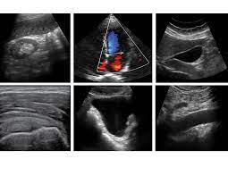

West Suffolk FUSIC and FAMUS Course

(Lung, Abdomen, vascular and DVT)

Date 7th of November 2025

Venue Ashlar House, 23 Eastern Way , Bury St Edmunds, Suffolk, IP32 7AB

Contact [kushbhowmick@gmail.com](mailto:kushbhowmick@gmail.com); [drgvk2005@doctors.org.uk](mailto:drgvk2005@doctors.org.uk); abbie.gray@wsh.nhs.uk;

**Programme**

|  |  |
| --- | --- |
| **Time** |  |
| **08:30 - 08:50** | Registration |
| **08:50 - 09:00** | Introduction |
| **09:00 - 10:45** | Introduction to chest Ultrasound with scanning demo  Abdominal ultrasound including trauma, ascites and paracentesis  Lecture on DVT scanning |
| **10:45- 11:00** | **Coffee and Break** |
| **11:00 - 12:40** | Scanning workshop on lung, abdominal, DVT, vascular access, lung and abdominal paracentesis. |
| **12:40 - 13:30** | **Lunch** |
| **13:30 - 14:00** | Lung US: pneumothorax, effusion and consolidation with case studies. |
| **14:00 –15:00** | Scanning workshop on lung, abdominal, DVT, vascular access, lung and abdominal paracentesis |
| **15:00 –15:15** | **Coffee and Break** |
| **15:15 -15:55** | Scanning workshop on Lung, abdominal, DVT and vascular ultrasound |
| **15:55 – 16:30** | FAMUS Overview: Training path, accreditation, archiving and reporting. |
| **16:30** | **Q&A and Close** |

**Please ensure you read the pre-course material to maximise your learning from the course.**