QMC Post Graduate Medical Education Centre (PGMEC)

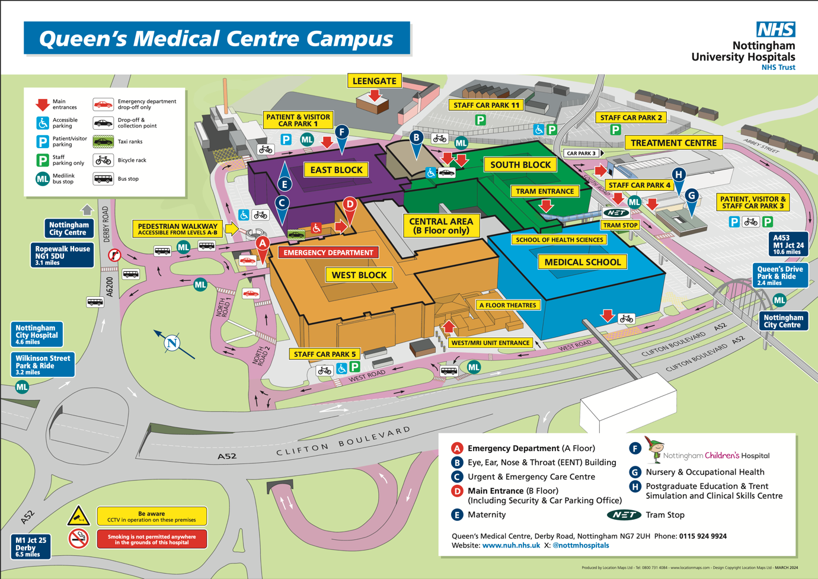
Derby Road, Nottingham - NG7 2UH - Location H
/// foam.wallet.last

Driving
M1 J25. Access via A52, parking in public car park 3. 2-4 hours = £5.50
Or Park & Ride and tram from Toton Lane P&R /// stir.images.wings (allow 25 mins)
Park & Ride and Medilink Bus from Queens Drive P&R /// pepper.known.engine (allow 20 mins)

Train & Tram
Nottingham Station and tram to QMC (stops adjacent to PGMEC)

