QMC Post Graduate Medical Education Centre (PGMEC)

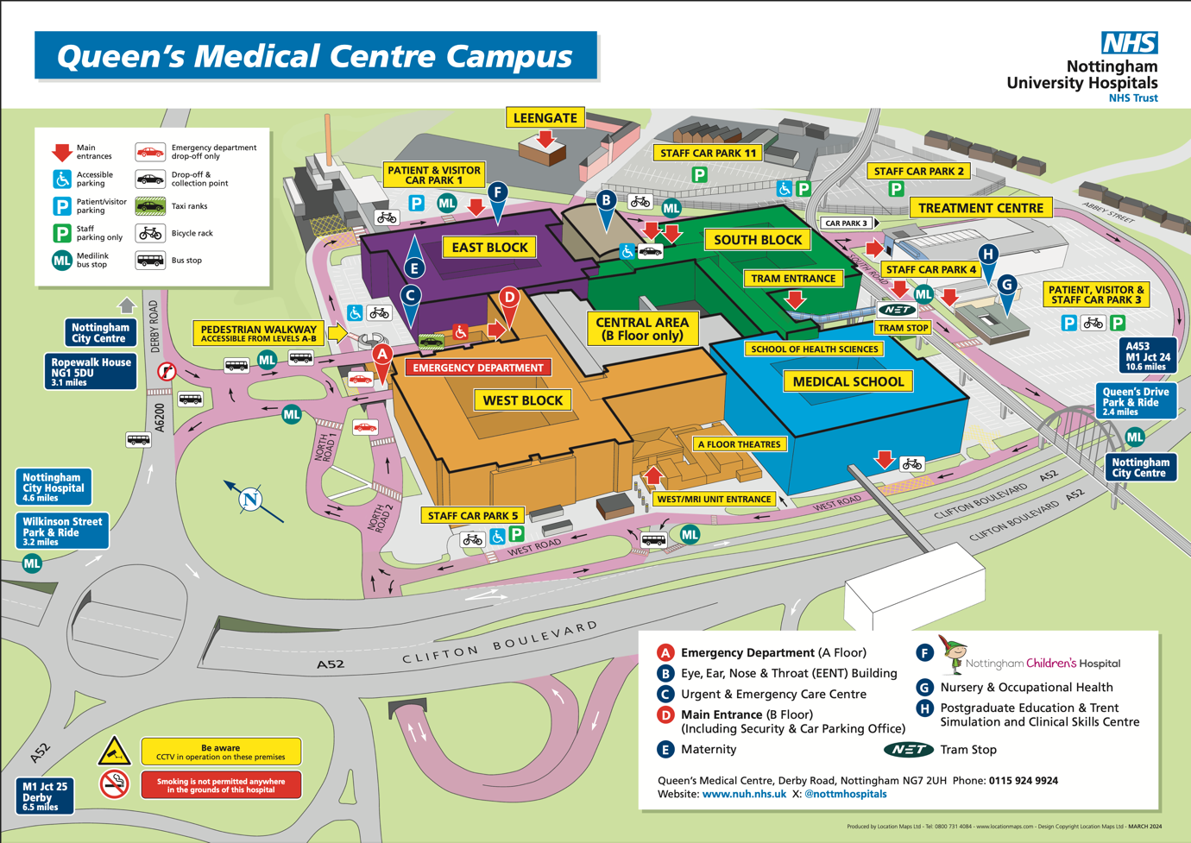
Derby Road, Nottingham - NG7 2UH - Location H
/// foam.wallet.last

Driving
M1 J25. Access via A52, parking in public car park 3. 2-4 hours = £5.50
Or Park & Ride and tram from Toton Lane P&R /// stir.images.wings (allow 25 mins)
Park & Ride and Medilink Bus from Queens Drive P&R /// pepper.known.engine (allow 20 mins)

Train & Tram
Nottingham Station and tram to QMC (stops adjacent to PGMEC)

Nottingham DAS Airway Roadshow

Time | Event | Speaker
12:30-13:15 | Lunch and drop in workshops
13:15–13:20 | WELCOME | Dr Mark Barley & Prof Alistair McNarry
13:20-13:50 | AEROendoscopy | Prof Reza Nouraei
13:50-14:10 | Red flags in airway management | Dr Mark Barley
14:20-14:50 | Awake Videolaryngoscopy | Prof Alistair McNarry
14:50-15:20 | COFFEE
15:20-15:50 | High Risk Extubation | Dr Sneh Shah
15:50-1620 | Economic and environmental realities of single use devices | Dr Rob McCahon  & Jennifer Gregory
16:20-Close | Drop in workshops
Delegates are encouraged to access the following workshops, which run in parallel to the presentations:

Drop-in workshops (20 mins):

Nasendo

Video assisted fibreoptic intubation (VAFI)

Awake fibreoptic intubation / ORSIM

Low Skill Fibreoptic Intubation
This meeting is generously sponsored by
