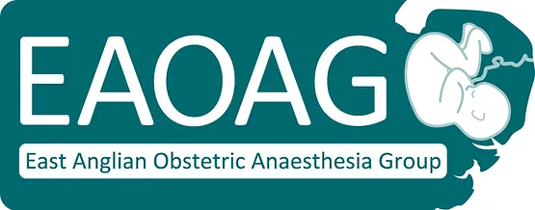
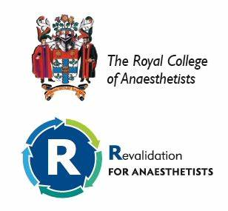
ANNUAL SCIENTIFIC MEETING
Trinity Park Ipswich 27th September 2024

08:30 Registration, coffee and trade exhibition
09:10 WELCOME
09:15 Assessing the impact of pre-existing renal disease on pregnancy: forward planning and reducing the risk for mother and baby
Dr Mark Andrews, Norfolk and Norwich University Hospital
09:55 The GOALPOSTs multicentre audit- Sharing and comparing obstetric anaesthesia outcomes in London and South East
Dr Matt Wikner, The Royal London Hospital
10:35 Questions and discussion
10:45 Break and trade exhibition (Lumbar Ultrasound Workshop Session 1)
11:25 Trainee Presentations
12:25 Update in Obstetrics
Miss Jo Cook, Ipswich Hospital
12:55 Questions and discussion
13:05 Lunch, trade exhibition and poster presentations (Lumbar Ultrasound Workshop Session 2)
13:45 NAP7- OBSTETRICS
Dr Nuala Lucas, Northwick Park Hospital
14:25 What’s new in postpartum haemorrhage
Dr Sarah Bell, Cardiff and Vale University Health Board
15:15 Questions and discussion
15:25 Break and trade exhibition
15:45 Preparing for the rising challenge of obesity
Dr Matt Simpson, St James’s University Hospital, Leeds
16:25 Questions and discussion
16:30 Presentation of prizes and close
Getting There
Trinity Park Conference Centre, Felixstowe Road, Ipswich IP3 8UH
By Car
For Sat Nav Systems please enter postcode IP3 8UH
From the A14: Trinity Park is on the outskirts of Ipswich, just off the A14. From the A14 take the exit sign-posted Lowestoft A12 and Ipswich East. At the roundabout take the A1156 towards Ipswich.(From the West this will be the third exit and you will pass under the flyover, from the East this will be the first exit). Travel for a little over a mile, passing a Honda Garage on your right, until you come to a roundabout. Take the third exit to enter Trinity Park.
From the South- London, Chelmsford and Colchester: Travel along the A12 until it joins the A14 and follow signs for Felixstowe, travelling over the Orwell Bridge. Follow signs from the A14 detailed above.
From the North-Lowestoft & Great Yarmouth: Exit the A12 at the Seven Hills Roundabout, pass under the bridge(A14) and follow the A 1156 towards Ipswich. Travel a little over a mile, passing a Honda Garage on your right, until you come to a roundabout. Take the third exit to enter Trinity Park.
By Rail
Trinity Park is 5 miles from Ipswich Railway Station. There are regular services to London, Norwich and Cambridge.
By Bus
There are bus connections from Ipswich and Felixstowe via routes 75,76,& 77. ‘Suffolk on Board’ website can provide bus times, your nearest bus route and connections.

The East Anglian Group of Obstetric Anaesthetists ASM will take place on Friday 27th September at Trinity Park Conference Centre, Felixstowe Road, Ipswich IP3 8UH. The conference centre is set in 350 acres of grounds and is host to a number of regional events including The Suffolk Show. It is easily accessible by road, and has on site car parking facilities.
We hope that the meeting will appeal to all grades of anaesthetist as the talks include an array of informative and topical subjects from national experts. The meeting also includes an opportunity for trainees in the eastern region to present audits, abstracts, research and interesting case studies; in addition to this we have included a free Lumbar Ultrasound workshop on a first come first serve basis (numbers limited to 20). There will be a trade exhibition throughout the day. Application for 5 CPD points, awaiting RCOA approval.

