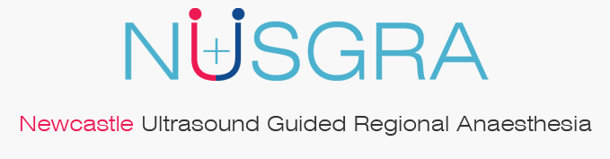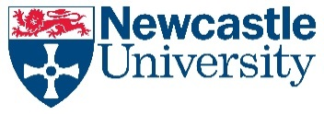

|  |
| --- |
|  |
| 18th Newcastle Ultrasound Guided Regional Anaesthesia Cadaver Needling Course |
| **16th & 17th January 2025** |

**Venue:**

**Dept of Anatomy & Clinical Skills**

**School of Medicine; Newcastle University; Framlington Place NE2 4HH**

(Closest Metro – Hay Market; Parking: Paid Parking available on Claremont Road car park NE2 4AA)

16th Jan 2025 (Thursday)

**8:30-9:00 – Registration**

|  |
| --- |
| 9:00- 9:30 - LECTURE  Ultrasound Physics & Scan Optimisation - Lecture |

|  |
| --- |
| 09:30- 10:15- Ultrasound Knobology & Needling practice on Phantom Gel/ Turkey Legs |

**10:15-10:30 Refreshment Break**

|  |
| --- |
| 10:30 to 11:00- Upper Limb Sonoanatomy  Above Clavicle (ISC/ SUPRACLAV. / Upper trunk) – Lecture & Demo |

|  |
| --- |
| *11:00 – 12:15 – Cadaveric anatomy demonstration-*  *- Model Scanning & Cadaveric Needling* |

**12:15-13:00 Lunch**

|  |
| --- |
| 13:00 – 13:30 – LECTURE/ Demo  Upper Limb Sonoanatomy-  Below Clavicle- (Infraclav. / Axillary/ Peripheral Nerves) – Lecture & Demo |

|  |
| --- |
| *13:30 – 15:00 – Cadaveric anatomy demonstration- Dr M Swamy*  *- Model Scanning & Cadaveric Needling* |

**15:00- 15:15 – Refreshment Break**

|  |
| --- |
| 15:15 – 15:45 - LECTURE / Demo  Torso/ Abdominal blocks- Sonoanatomy – PECS/ TAP / Rectus sheath & OtherS – Lecture & Demo |

|  |
| --- |
| *15:45- 17:00 - Cadaveric anatomy demonstration- Dr M Swamy*  -  *Model Scanning & Cadaveric Needling* |

17th January 2025 (Friday)

**8:00-8:30 – Registration**

|  |
| --- |
| 08:30– 09:00 LECTURE  LA Toxicity & Safety in Regional Anaesthesia – Dr Mo Mohamed |
|  |

|  |
| --- |
| **09:00-09:30- LECTURE / Demo**  **Sonoanatomy Lower limb- Fascia iliaca, Femoral, Obturator, Lateral Femoral Cutaneous Nerves / PENG / Adductor Canal– Lecture & Demo** |
|  |

|  |
| --- |
| 09:30 – 10:45 - *Cadaveric anatomy demonstration- Dr B Goodman*  - *Model Scanning & Cadaver Needling* |

**10:45 -11:00 - Refreshment Break**

|  |
| --- |
| 11:00 -11:30- LECTURE  Sonoanatomy - Lower limb- Sciatic, Popliteal, IPACK and Ankle blocks -  LECTURE & Demo |

|  |
| --- |
| 11:30 – 12:45 - *Cadaveric anatomy demonstration- Dr Goodman*  - *Model Scanning & Cadaveric Needling* |

12:45 – 13:30 LUNCH BREAK

|  |
| --- |
| 13:30-14:00– LECTURE  Sonoanatomy - Neuraxial, Paravertebral, ESPB  Dr Womack / Dr Goodman (Demo) (30 min) |

|  |
| --- |
| 14:00 – 15:15 - *Cadaveric anatomy demonstration- Dr B Goodman*  - *Model Scanning & Cadaver Needling* |

**15:15 – 15:30 Refreshment Break**

|  |
| --- |
| 15:30 – 17:30 – Delegates’ Time - Practice of Ultrasound Guided Cadaveric Needling Facilitator- Dr Womack |

|  |
| --- |
| 17:30 e-Feedback & e-Certificates |