# 

# Date: Wednesday 22.05.2024

**Duration(Days):**1

**Accreditation :** 7 CPD points -

**Availability:**Available

**Location :**Anaesthetic Department Seminar Room

Guy’s Hospital, Borough Wing 2nd floor

**Contact email:**

[Email organiser](https://bookcpd.com/email/node/521/field_contact_email)

**Fee options:**£70

tea and coffee included /no lunch

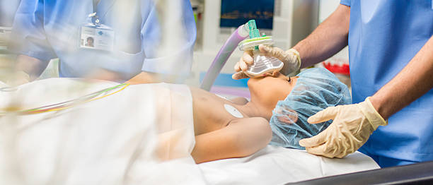

**Description**

Target audience :This Paediatric study day **Children are not small adults**

is aimed at Operating Department Practitioners and Anaesthetic Assistants emphasizing the unique needs of paediatric patients.

You will be able delve into the specifics of paediatric airway management, including the use of adjuncts and tubing sizes.

The study day has workshops where the participants rotate through various stations covering essential topics such as

* bag-valve-mask (BVM) ventilation,
* oropharyngeal and nasopharyngeal airways (OPA/NPA),
* supraglottic airways (SGA),
* endotracheal tubes (ETT), and
* managing difficult airways in paediatric patients.

an alternative session focusing on Paediatric Immediate Postoperative Care

The afternoon, is centred on obstetric anaesthesia. Participants engage in discussions and activities related to anaesthesia management during obstetric procedures, ensuring comprehensive knowledge and skill development in this specialized area.

Throughout the day, the seminar offers a structured and comprehensive agenda aimed at enhancing participants' understanding and proficiency in paediatric emergency medicine and obstetric anaesthesia.

Top of Form

|  |  |
| --- | --- |
| 09:00-09:45 | Children are not small adults |
| 09:45-10:15 | Paediatric airway adjuncts /tubing sizes |
| 10:15 – 10:30 | Break |
| 10:30-12:15 | Workshops   1. BVM, OPA, NPA 2. SGA 3. WETFLAG 4. ETT 5. Difficult airway in paediatrics |
| 12.15-13:00 | Lunch Break |
| 12:15 – 13:15  Or  13:00-14:00 | Paediatric Immediate Postoperative Care |
| 14:00-16:30 | Obstetric Anaesthesia |