SETSA 2024

|  |
| --- |
| South East Thames Society of Anaesthetists  Autumn Meeting  Wednesday, 16th October |
|  |

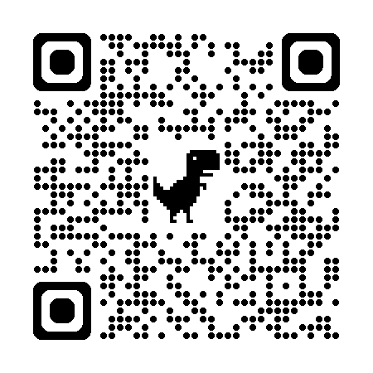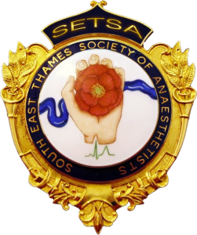

PM 2

PM 1

AM 2

13:45 – 15:15 Afternoon Workshops

Airway skills TIVA (TBC)

Regional anesthesia Echo (TBC)

15:15 – 15:45 Posters & trainee presentations

15:45 – 16:15 World anaesthesia day celebration

11:30 – 12:00 Dr A, Affiliation – TIVA

12:00 – 12:30 Dr B, Affiliation – Obstetric anaesthesia

09:30 – 10:00 Dr X, Affiliation – Keynote Speaker

10:00 – 10:30 Dr Y, Affiliation – Perioperative medicine

10:30 – 11:00 Dr Z, Affiliation – Obesity & anaesthesia

AM 1

09:00 – 09:15 Registration and tea/coffee

09:15 – 09:30 Welcome and introduction

11:00 – 11:30 Coffee break

12:30 – 13:45 Lunch & poster presentations

16:15 – 16:30 Prizes & conclusion

**Abstract Submission Deadline: 1st September, 2024**

Abstract guidelines at setsa-online.org.uk

**Book your place via BookCPD**