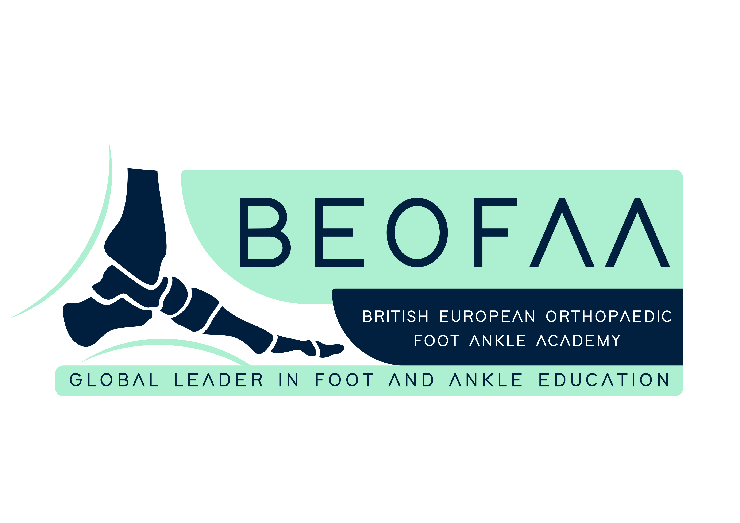
1ST BEOFAA ADVANCED FELLOW FORUM : 13/06/25 TO 14/06/25

Day 1: Friday 13th June 2025

08:30-09:00 Registration

09:00-09:15 Introduction and welcome to the 1st BEOFAA Advanced Fellow Forum

ROUND TABLE SESSION 1 – FOREFOOT (Chair Fellows)

09:15-09:30 Current controversies in forefoot surgery - Fellow

09:30-09:45 Functional outcome after fusion of 1st MTP Joint – Maneesh Bhatia

09:45-10:00 Hallux valgus with osteochondral lesion in 1st metatarsal head – Robert Clayton

10:00-10:30 Round table discussion

10:30-11:15 Tea & Coffee

11:15-11:30 Morton’s neuroma: Getting it right 1st time – Tim Clough

11:30-11:45 Minimum invasive forefoot surgery - Robbie Ray

11:45-12:00 Revision forefoot surgery – Manuel Monteagudo

12:00- 12:30 Round table discussion

12:30-13:30 Lunch

ROUND TABLE SESSION 2 SPORTS / TRAUMA (Chair Fellows)

13:30-13:45 Cartilage lesions of talus: Small and big – Current concepts – Nick Cullen

13:45-14:00 Role of endoscopy in tendon disorders Jesus - Vila y Rico

14:00-14:15 Modern concepts of Calcaneal fracture fixation – Antonio Dalmau

14:15-14:45 Round table discussion

14:45-15:30 Tea & Coffee

ROUND TABLE SESSION 3 – MAL UNION (Chair Fellows)

15:30-15:45 Mal union following ankle fractures – Hiro Tanaka

15:45-16:00 Mal union following talus fractures – Stefan Rammelt

16:00-16:15 Mal union following calcaneum fractures – Nikos Gougoulias

16:15- 16:45 Round table discussion

16:45- 17:30 Take Home Messages of the day (Fellows)

17:30-18:30 Drinks Reception

Day 2: Saturday 14th June 2025

ROUND TABLE SESSION 4 – MIDFOOT & HINDFOOT (Chair Fellows)

09:00-09:15 Flatfoot reconstruction (Osteotomy versus fusion) – Manuel Monteagudo

09:15-09:30 Cavovarus reconstruction including role of PSI – Karan Malhotra

09:30-09:45 Hindfoot reconstruction (Nails versus plates) – Mark Davies

09:45-10:15 Round table discussion

10:15-11:00 Tea & Coffee

ROUND TABLE SESSION 5 – ANKLE (Chair Fellows)

11:00-11:15 How to avoid fusion or replacement in ankle arthritis – Norman Espinosa

11:15- 11:30 Varus/Valgus deformity- Limits of Ankle arthroscopic fusion – Maneesh Bhatia

11:30-11:45 Varus/Valgus deformity- Limits of Ankle arthroplasty – Yasser Aljabi

11:45-12:15 Round table discussion

12:15-13:15 Lunch

ROUND TABLE SESSION 6 – Case based discussions (Chair Fellows)

13:15 – 14.30 Cracking cases (Case Presentation by Fellows)

14:30-15:15 Tea & Coffee

ROUND TABLE SESSION 6 – Case based discussions (Chair Fellows)

15:15-16:30 Golden Nuggets - A case that changed my career (BEOFAA faculty)

16:30-17:00 Thanks, Closing Ceremony & Best Fellow award

