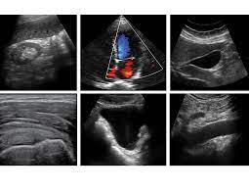

West Suffolk FUSIC Ultrasound Course

(Lung, Abdomen, vascular and DVT)

Date 2nd July 2024

Venue Ashlar House, 23 Eastern Way , Bury St Edmunds, Suffolk, IP32 7AB

Contact kushbhowmick@gmail.com; drgvk2005@doctors.org.uk;

Programme
Time
08:30 - 08:50 | Registration
08:50 - 09:00 | Introduction
09:00 - 10:30 | Lectures to include:  Introduction to chest Ultrasound  Lecture: Abdominal ultrasound including trauma, ascites and paracentesis
10:30- 10:45 | Coffee and Break
10:45 - 12:30 | Lung US Lecture: pneumothorax, effusion and consolidation  Lecture: Vascular access ultrasound, newer techniques, DVT screening
12:30 - 13:30 | Lunch
13:30 - 14:30 | Scanning workshop on live volunteers, simulator and practical models
14:30 –14:50 | Coffee and Break
14:50 - 15:30 | Scanning workshop on Lung, abdominal, DVT and vascular ultrasound
15:30 - 16:00 | FUSIC Overview: Training path, accreditation, archiving and reporting.
16:00 - 16:30 | Questions and Feedback session
16:30 | Close

Please ensure you read the pre-course material to maximise your learning from the course.

