 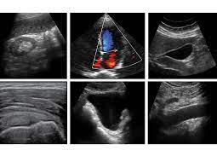

West Suffolk FUSIC and FAMUS Course

(Lung, Abdomen, vascular and DVT)

Date 22nd of October 2024

Venue Ashlar House, 23 Eastern Way , Bury St Edmunds, Suffolk, IP32 7AB

Contact [kushbhowmick@gmail.com](mailto:kushbhowmick@gmail.com); drgvk2005@doctors.org.uk;

**Programme**

|  |  |
| --- | --- |
| **Time** |  |
| **08:30 - 08:50** | Registration |
| **08:50 - 09:00** | Introduction |
| **09:00 - 10:30** | Introduction to chest Ultrasound with scanning demo  Abdominal ultrasound including trauma, ascites and paracentesis  Scanning demo of abdomen. |
| **10:30- 10:45** | **Coffee and Break** |
| **10:45 - 12:30** | Lung US demo: pneumothorax, effusion and consolidation (on volunteer and simulator)  Lecture and scanning demo of vascular access, DVT screening |
| **12:30 - 13:00** | **Lunch** |
| **13:00 - 14:30** | Scanning workshop on lung, abdominal, DVT, vascular access, lung and abdominal paracentesis. |
| **14:30 –14:45** | **Coffee and Break** |
| **14:45 - 16:15** | Scanning workshop on Lung, abdominal, DVT and vascular ultrasound |
| **16:15 – 16:30** | FUSIC Overview: Training path, accreditation, archiving and reporting. |
| **16:30 – 17:00** | FAMUS accreditation overview: Training path |
| **17:00** | **Q&A and Close** |

**Please ensure you read the pre-course material to maximise your learning from the course.**