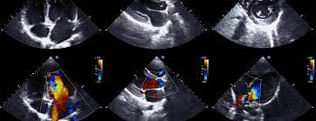

West Suffolk FUSIC Heart Ultrasound Course

Date 1st of July 2024

Venue Ashlar House, 23 Eastern Way, Bury St Edmunds, Suffolk, IP32 7AB

Contact: kushbhowmick@gmail.com; drgvk2005@doctors.org.uk

Programme
Time
08:30 - 08:50 | Registration
08:50 - 09:00 | Introduction
09:00 - 10:15 | Lectures to include:  Ultrasound Physics  FUSIC heart image set
10:15- 10:30 | Coffee Break
10:30 – 11:45 | Scanning workshop including focused echo  Hands on experience on volunteers and simulator
11:45 – 12:45 | Lectures on Left and Right Ventricle assessment
12:45 – 13:30 | Lunch
13:30 - 14:15 | Lecture session on volume assessment  Lecture session on use of echocardiography in Shock
14:15 – 15:00 | Scanning workshop include basic measurements
15:00 – 15:15 | Coffee Break
15:15 – 15:45 | Scanning workshop include basic measurements
15:45 – 16:15 | Quiz
16:15 – 16:45 | FUSIC accreditation process
16:45 – 17:00 | Q&A followed by close

Please ensure you read the pre-course material to maximise your learning from the course.

