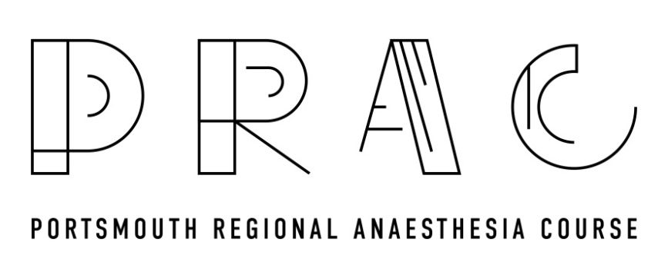

18th October, 2024
08:30-09:00 Registration and coffee
09:00-09:20 Upper limb blocks above the clavicle: demonstration on model
09:20-09:40 Upper limb blocks below the clavicle: demonstration on model
09:40-10:30 Live scanning of above blocks by participants
Group A | Group B | Group C | Group D | Group E

10:30-11:00 Coffee
11:00-11:15 Catheter insertion - Clinical pearls.
11:15-12:15 Live needling/catheter insertion practise
Group A | Group B | Group C | Group D | Group E

12:15-13:00 Lunch & Networking
13:00-13:20 Regional anaesthesia for Rib fractures: demonstration on model

13:20-13:40 Ultrasound for Neuraxial Procedures: demonstration on model

13:40-14:30 Live scanning of above blocks by candidates
Group A | Group B | Group C | Group D | Group E

14:30-14:45 Coffee

14:45-15:00 Nerve blocks for Hip and Knee surgery: demonstration on model

15:00-15:15 Nerve blocks for foot and ankle surgery: demonstration on model
15:15-16:15 Live scanning of above blocks
Group A | Group B | Group C | Group D | Group E

16:15-16:30 Summary/Questions

