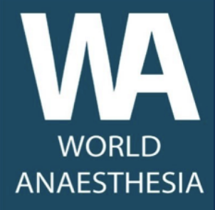
WAS Seminar program 10th July 2023

0945 Link opens
1000 – 1010 WAS presidential address Sarah Davidson

Sustainable connections:
1010-1040 ZADP, Emma Coley, Masuzyo Zyambo and Sonia Akrimi
1040-1110 THET, Richard Skone-James

***1110 – 1115 Break***

1115 – 1145 WFSA, Amal Paonaskar

Career Sustainability:
1145-1215 Mike Dobson

Organisational sustainability
1215-1245 Discussion Panel: Locations of leadership, the future of HIC led organisations in global work, session leads and WFSA CEO Kristine Staves, CANECSA President Mpoki Ulisubisya

***1245-1330 Lunch***

1330-1350 Poster Presentations

Environmental Sustainability:
1350-1420 Environmental change and its impact on, LMICs SanYuMay Tun
1420-1450 Anaesthesia and the environment, Paul Southall

***1450-1500 Break and medical student poster presentation***

1500-1530 Sustainability of donations, Robert Neighbour
1530-1600 Discussion Panel: Balancing growth with environmental sustainability, previous speakers and Liz Tissingh

Summary and closing remarks
1600-1615 Next steps for WAS and closing remarks, Sarah Davidson

