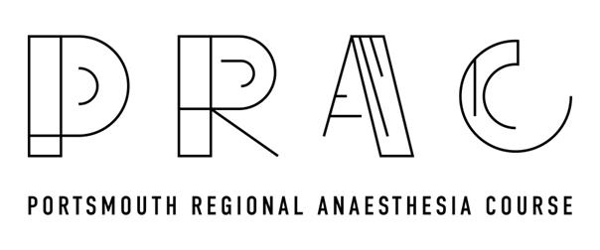
6TH October 2023
CPD MATCHED PROGRAMME

Pre-course information and reading (3A09, 2G01, 2G02, 2G03, 2G04)
08:30-09:00 Registration and coffee
09:00-09:20 Supraclavicular and Interscalene Talk & Blocks demonstration on Model (3A09,2G02)
09:20-09:40 Axillary and distal Talk & Blocks demonstration on Model (3A09)
09:40-10:30 Live scanning of above blocks by candidates in groups of 4 (3A09)
10:30-11:00 Coffee
11:00-11:15 Needling and Catheter insertions: Practical tips(3A09)
11:15-12:15 Needling/catheter insertion practise on animal models in Wet lab (3A09)
12:15-13:00 Lunch
13:00-13:20 Fascia Iliaca/Femoral/Adductor canal Talk & Block demonstration on Model (3A09,2G02)
13:20-13:40 Popliteal and Ankle Talk & Block demonstration on Model (3A09)
13:40-14:20 Live scanning of above blocks by candidates in groups of 4 (3A09)
14:20-14:45 Coffee
14:45-15:05 SA and PEC BLOCKS Talk & demonstration on Model (3A09, 2G02)
15:05-15:25 Paravertebral and ES Block Talk & demonstration on Model (3A09)
15:25-16:10 Live scanning of above blocks by candidates in groups of 4 (3A09)
16:00-16:15 Portsmouth Rib Fracture Pathway & Managing Postoperative Pain when block wears Off
16:15-16:30 Spine US, Additional topics requested by participants/Q and A/Feedback/Summary

