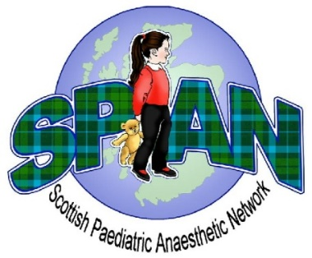

Scottish Paediatric Anaesthetic Network Annual Spring Meeting
20 May 2022
Waldorf Astoria Hotel, Edinburgh
Registration on BookCPD website

8.50 - 9.00 Welcome
9.00 - 9.35 Trainee presentations
9.35 - 10.10 New European Fasting Guidelines in paediatric anaesthesia
Dr Peter Frykholm, Uppsala
10.10 -10.45 ‘Gloves are off’ campaign Helen Dunn, London

10.45 - 11.00 Coffee break

11.00- 11.35 Designing Children’s Surgical Service Dr Grant Rodney, Dundee
11.35- 12.05 Art and healing Suzanne Scott, Dundee
12.05 -12.40 Strategies to reduce the risk of perioperative airway adverse
events Dr Clyde Matava, Toronto

12.40 -13.40 Lunch break / Trade presentations

13.40- 14.30 AGM
13.30 -14.15 Trainee meeting TBC
14.15 -14.40 Setting up the preassessment service Dr Paul Fettes, Dundee
14.40 -15.00 Morbidity and Mortality meeting
15.00 -15.20 TBC Dr Cas Findlater, Edinburgh

15.20 - 15.50 Coffee break/ Poster presentations

15.50 - 16.25 Updates from recent trials (Nectarine/PAWS)
Professor Thomas Engelhardt, Montreal /Jacob Karlsson)
16.25 – 16.55 Paediatric processed EEG Dr Tom Blanks, Nottigham
16.55 - 17.00 Meeting close

Programme subject to change

