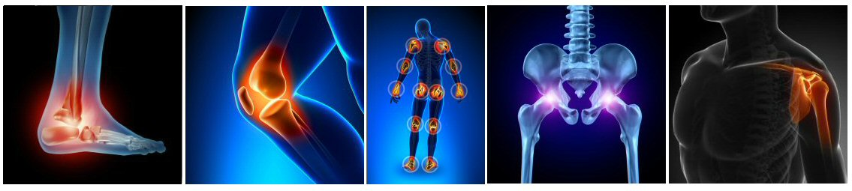

3rd Joint Pain Management - Arthritis Workshop
12th March 2022

Leicester Marriott Hotel, Smith Way, Grove Park Enderby,

Leicester LE19 1SW
Organisers- Mr Maneesh Bhatia, Dr Sadiq Bhayani & Dr Rahul Bhansali

8.30 – 9.00 am Registration, snacks, Tea & Coffee

9.00-9.10 Welcome

9.10-9.30 Medical management of Arthritis
Dr Arumugam Moorthy (Consultant Rheumatologist)
9.30-9.50 Surgical management of Arthritis – Hand & Wrist
Mr Harvinder Singh (Consultant Orthopaedic surgeon)
9.50-10:10 Surgical management of Arthritis - Shoulder & Elbow
Mr R Pandey (Consultant Orthopaedic surgeon)
10:10-10:30 Physiotherapy for Arthritis – Upper limb
Helen Tunnicliffe (MSK Physiotherapist)

10:30-10.45 Discussion & Questions

10.45-11.00 Coffee break

11:00-11:20 Surgical management of Arthritis - Hip & Knee
Mr Arijit Ghosh (Consultant Orthopaedic Surgeon)
11:20-11:40 Surgical management of Arthritis – Foot & Ankle
Mr Maneesh Bhatia (Consultant Orthopaedic Surgeon)
11:40-12:00 Physiotherapy for Arthritis - Lower Limb
Rachel Calver (MSK Physiotherapist)
12:00-2:20 Pain management of Arthritis
Dr Sadiq Bhayani (Consultant in Pain Medicine)
12:20-12:40 Discussion & Questions

12:40-13:30 Thanks, Feedback, Lunch & Close

