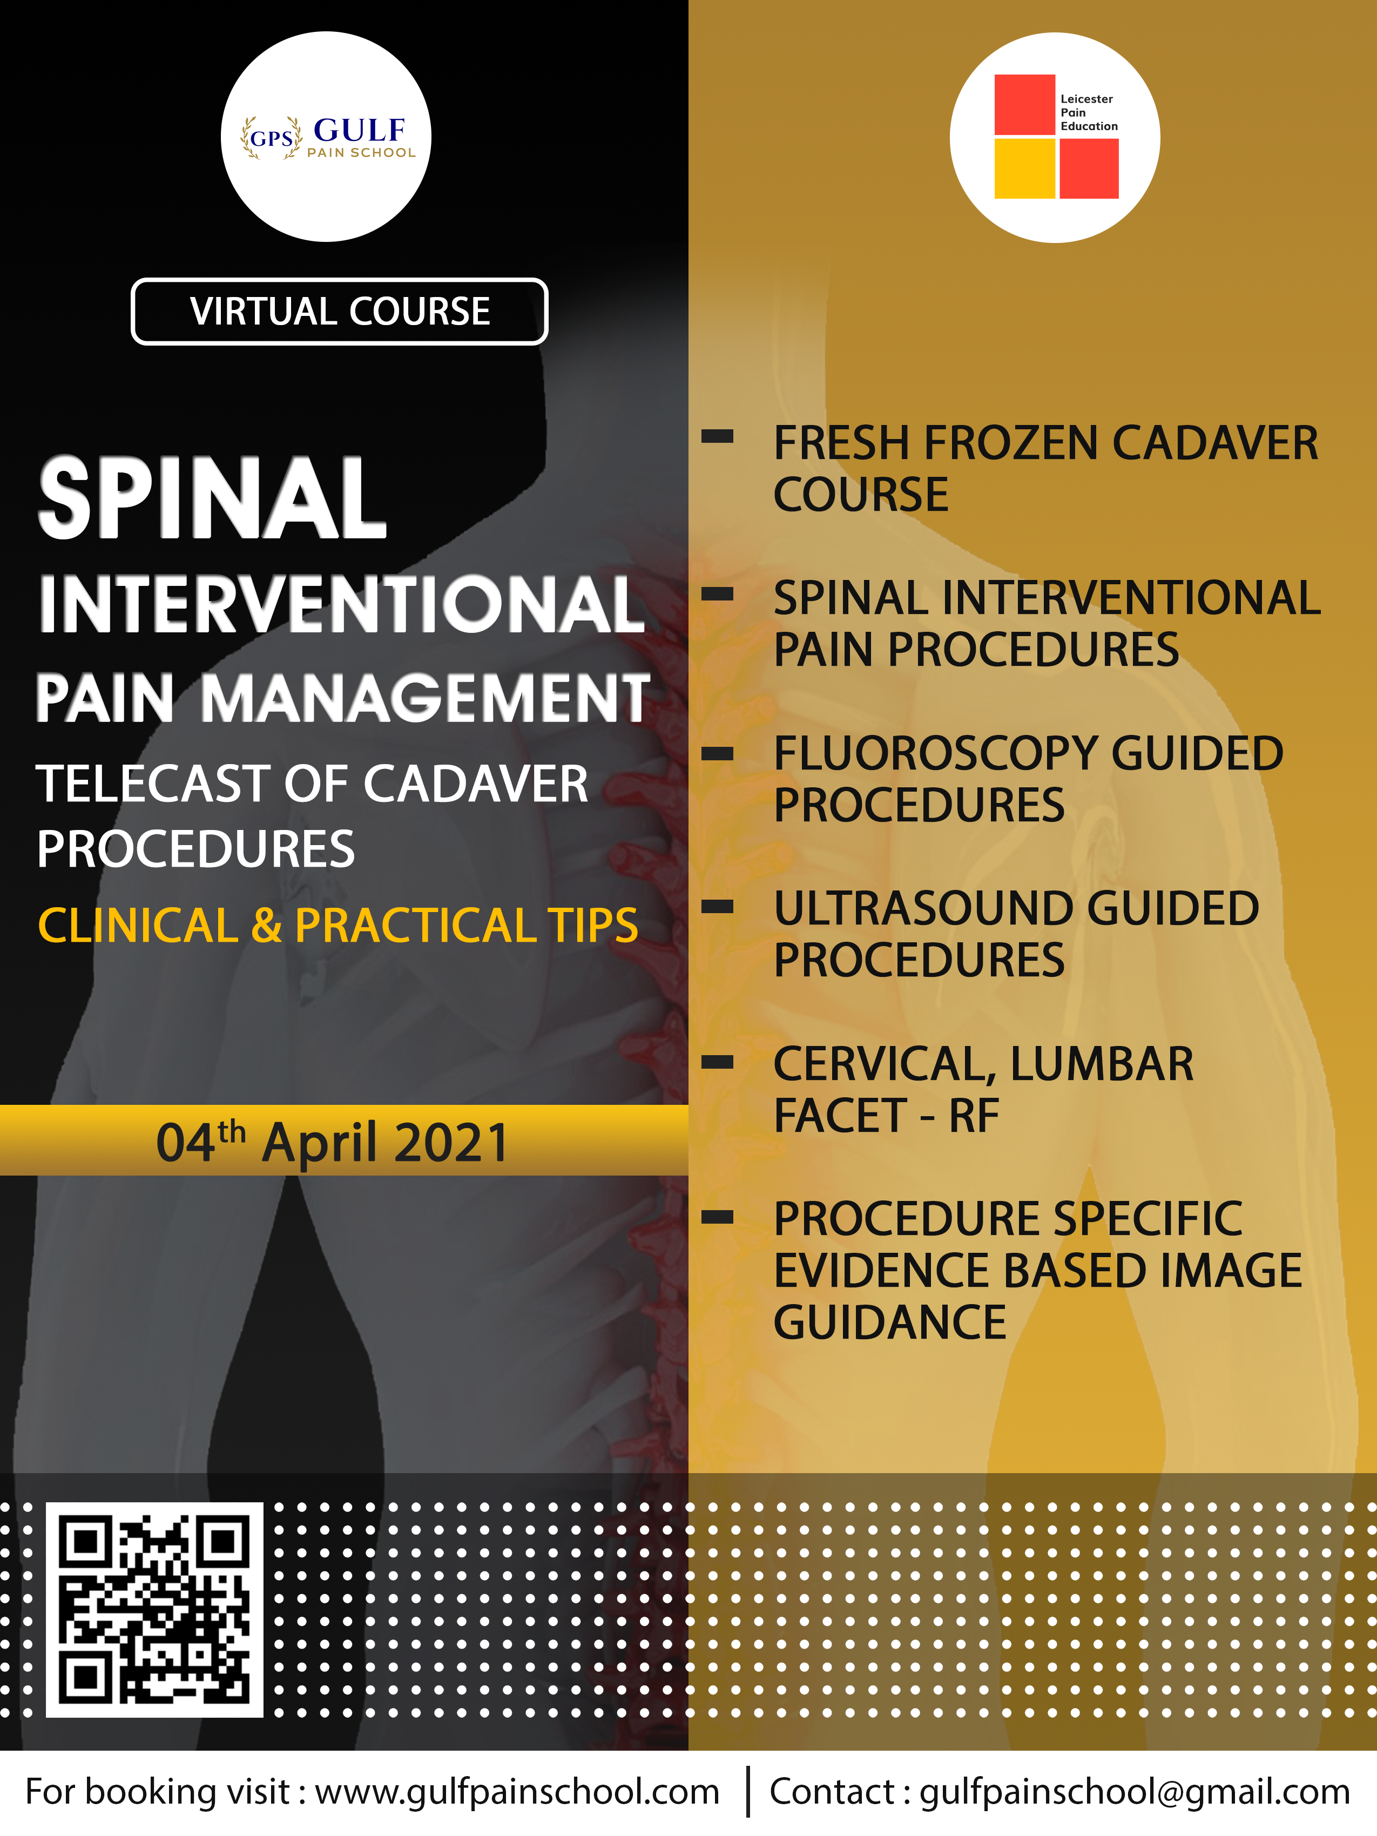

Leicester Pain Education & Gulf Pain School
Spinal Interventional Pain Management
Web Casting of Cadaveric Procedures
4 April 2021
3pm UK Time/ 6pm UAE Time
All lectures recorded for on demand viewing
Approval sought for 4 CPD Points from Royal College of Anaesthetists, United Kingdom
Program
3.00-3.15pm- Check in & instructions
3.15-4.45pm- How do I do it? Lecture & Cadaver Web casting of Cervical Spine Procedure
4.45-4.55pm- Questions and Answer
4.55-5.00pm- Coffee Break
5.00-6.00pm- How do I do it? Lecture & Cadaver Web casting of Lumbar Spine Procedure
6.00-6.10pm- Questions and Answer
6.10-6.15pm- Coffee Break
6.15-7.15pm- How do I do it? Lecture & Cadaver Web casting of Sacral Procedures
7.15-7.25- Questions and Answer
7.25-7.30pm- Instructions & close

Procedures Covered

Cervical Spine
Cervical Facet, Cervical Medial branch RF, Third Occipital Nerve, Occipital RF

Lumbar Spine
Lumbar Facet Joint , MBB & RF, Transforaminal ESI

Sacral and Other Procedures
Caudal, Ganglion impar block, Sacro-illiac joint injection,
SIJ Bipolar RF, Piriformis injection

