Cambridge EDRA Part I and Part II Preparation Course
7th April 2020
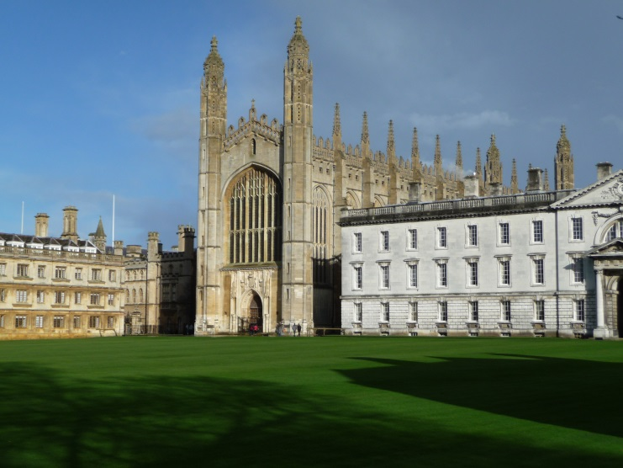
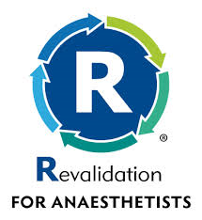
- Experienced and distinguished faculty
- EDRA prep course for those taking EDRA Exam
- CPD recognition applied for from Royal College of Anaesthetists
- RA-UK approved course
- To book a place on the course please follow this link:
https://www.eventbrite.ca/e/cambridge-cadaveric-anatomy-and-us-guided-regional-anaesthesia-course-registration-78878300119?utm_term=eventurl_text

