Cambridge Cadaveric Anatomy and Ultrasound Guided Regional Anaesthesia Course
5th-7th April 2020
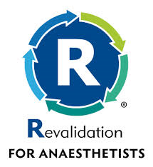
- Experienced and distinguished faculty
- Small group teaching of Ultrasound Guided Nerve blocks
- Cadaveric anatomy teaching on prosections
- Lectures by experts in regional anaesthesia
- EDRA prep course for those taking EDRA Exam
- CPD recognition from Royal College of Anaesthetists for 15 points
- RA-UK approved course
- To book a place on the course please follow this link:
https://www.eventbrite.ca/e/cambridge-cadaveric-anatomy-and-us-guided-regional-anaesthesia-course-registration-78878300119?utm_term=eventurl_text

