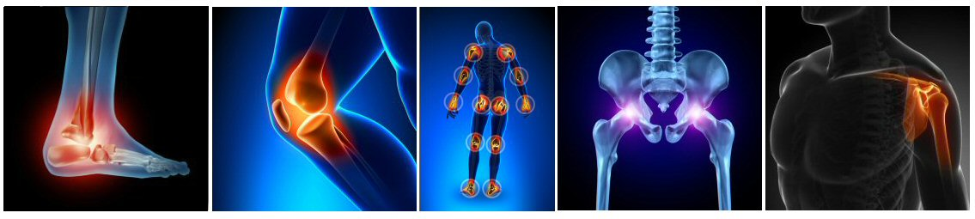

3rd Joint Pain Management - Arthritis Workshop
31st March 2020

Leicester Marriott Hotel, Smith Way, Grove Park Enderby,

Leicester LE19 1SW

Organisers- Mr Maneesh Bhatia, Dr Sadiq Bhayani & Dr Rahul Bhansali

18:30-19:00 Registration, snacks, Tea & Coffee

19.00-19.05 Welcome

19.05-19.15 Medical management of Arthritis
Dr Arumugam Moorthy (Consultant Rheumatologist)
19.15-19.25 Surgical management of Arthritis – Hand & Wrist
Mr Aamer Ullah (Consultant Orthopaedic surgeon)
19.25-19:35 Surgical management of Arthritis - Shoulder & Elbow
Mr R Pandey (Consultant Orthopaedic surgeon)
19.35-19.45 Physiotherapy for Arthritis – Upper limb
Helen Tunnicliffe (MSK Physiotherapist)

19:45-20.00 Discussion & Questions

20.00-20.10 Surgical management of Arthritis - Hip & Knee
Mr Arijit Ghosh (Consultant Orthopaedic Surgeon)
20.10-20.20 Surgical management of Arthritis – Foot & Ankle
Mr Maneesh Bhatia (Consultant Orthopaedic Surgeon)
20:20-20.30 Physiotherapy for Arthritis - Lower Limb
Richard Wood (MSK Physiotherapist)
20:30-20:40 Pain management of Arthritis
Dr Sadiq Bhayani (Consultants in Pain Medicine)
20:40-20:50 Psychiatric support for Arthritis
Dr Ashish Arora (Consultant Psychiatrist)

20:50– 21:00 Discussion & Questions

21.00 Thanks, Feedback and Close

