“ISAKOS APPROVED LEARNING CENTER” Cwm Taff Morgannwg University Health Board
Basic Knee Arthroplasty Course
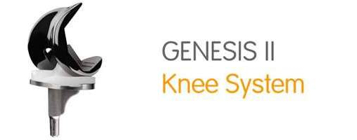
LIVE SURGERY
LECTURES and SAW BONE WORSKHOPS
The course is aimed at all levels of ORTHOPAEDIC SURGEONS

Date: Wednesday 22th May 2019 Time: 8.00am to 6.00pm
Venue: MPEC building, Princess of Wales Hospital, Bridgend, CF31 1RQ

Course convenor: Mr Amit Chandratreya
Faculty:
Prof K Singhal, Mr D Robinson, Mr Stuart Roy, Mr Sanjeev Agarwal, Mr Mark Forster and Mr Rahul Kotwal.
Co-ordinator: Mr Wahid Abdul

Accredited by the Royal College of Surgeons of Edinburgh: 6 CPD points awarded
To register, go to https://bookcpd.com/course/basic-knee-arthroplasty-course
Contact email Alisa.Bourne@wales.nhs.uk
(delegate number restricted to 18) Registration fees: £100
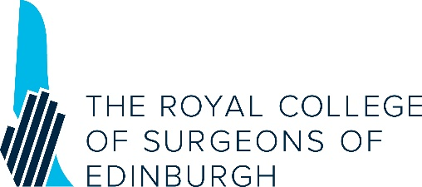
Disclaimer: if live surgery is not possible for logistical reasons, pre-recorded TKR surgery will be shown.

