5th North East Region Difficult Airway Society (NERDS) Workshop
Thursday 5th March 2020
Institute of Transplantation, Level 4
Freeman Hospital, Newcastle upon Tyne

Course aims:

- To allow delegates to learn, refresh or update skills in managing the difficult airway
- To provide practical hands-on experience in common difficult airway techniques
- To discuss real-life difficult cases and role of human factors in managing the difficult airway

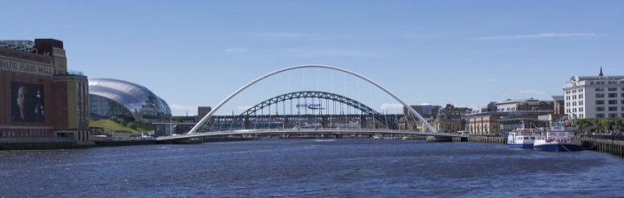

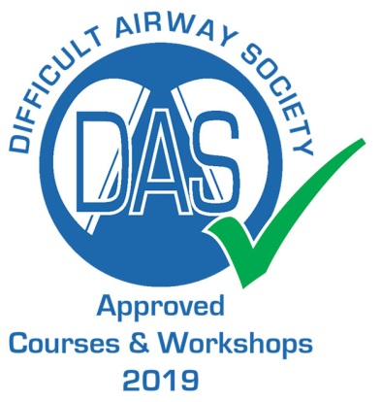
A programme of lectures and workshops covering:

Paediatric airway
Airway exchange techniques, staged extubation
Oral & nasal flexible bronchoscopic intubation
Simulated scenarios
Difficult obstetric airway
Tracheostomy trouble-shooting
Videolaryngoscopy
Front of Neck airway (surgical cricothyroidotomy)
Case based discussions
Shared airway techniques – jet ventilation, High Flow Nasal Oxygen
Surgeon’s perspective on the difficult airway
Decision-making and human factors considerations

5 CPD points applied for
To book please visit: https://bookcpd.com/course/nerds-5th-airway-workshop

Course fees including lunch and refreshments:
Consultants: £150; Trainees and SAS doctors: £125; Allied health professionals: £100

