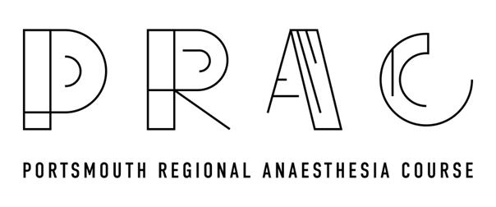
18TH OCTOBER, 2019
CPD MATCHED PROGRAMME

Pre-course information and reading (3A09, 2G01, 2G02, 2G03, 2G04)
08:30-09:00 Registration and coffee
09:00-09:20 Supraclavicular and Interscalene Talk & Blocks demonstration on Model (3A09,2G02)
09:20-09:40 Axillary and distal Talk & Blocks demonstration on Model (3A09)
09:40-10:30 Live scanning of above blocks by candidates in groups of 4 (3A09)
10:30-10:50 Coffee
10:50-11:30 Needling/catheter insertion practise on animal models in Wet lab (3A09)
11:30-12:00 Discussion with Faculty (3A09, 2G01, 2G02, 2G03, 2G04)
12:00-12:45 Lunch
12:45-13:05 Fascia Iliaca/Femoral/Adductor canal Talk & Block demonstration on Model (3A09,2G02)
13:05-13:25 Popliteal and Ankle Talk & Block demonstration on Model (3A09)
13:25-14:15 Live scanning of above blocks by candidates in groups of 4(3A09)
14:15-14:30 Coffee
14:30-14:50 SA and PEC BLOCKS Talk & demonstration on Model (3A09, 2G02)
14:50-15:10 Paravertebral and ES Block Talk & demonstration on Model (3A09)
15:10-16:00 Live scanning of above blocks by candidates in groups of 4 (3A09)
16:00-16:15 Portsmouth Rib Fracture Pathway (3E00)
16:15-16:45 Additional topics requested by participants/Q and A/Feedback/Summary

