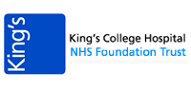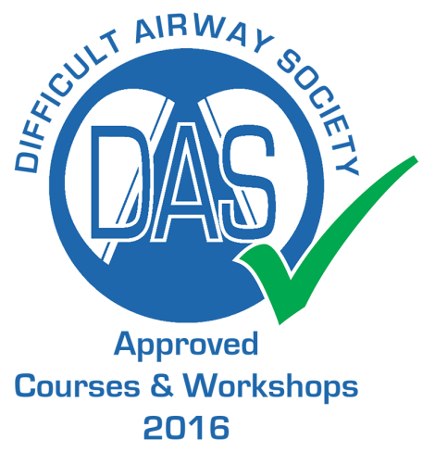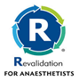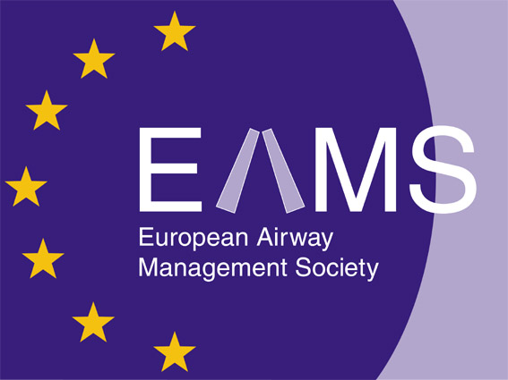
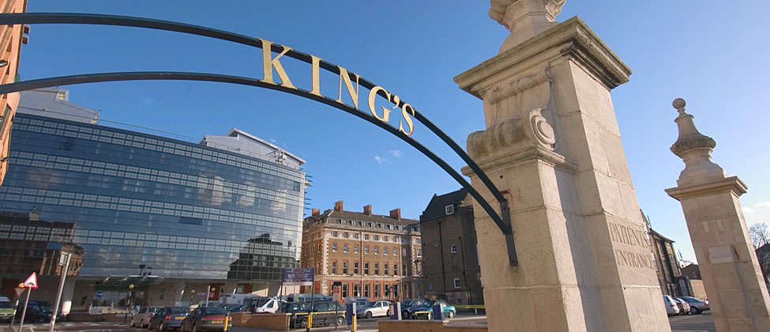

27th King’s Difficult Airway Management Workshop
Date: Thursday 5th October 2017
Venue: Weston Education Centre, King’s College Hospital,
Denmark Hill, London, UK SE5 9RS
Programme

09:00 - 10:00 Registration and coffee | 10:00 - 12:30 Morning session (5 stations)
12:30 - 13:30 Lunch | 13:30 - 16:00Afternoon session (5 stations)
Practical Hands on Experience
- Nasal and Oral Fibreoptic intubation  - Staged extubation  - ORSIM Simulated airway trainer  - Supraglottic airway devices,  - Rescue intubation via LMA  - NAP4 Surgical front of neck access  - Ultrasound guided airway management | - Videolaryngoscopes (non-channelled) Glidescope, C-Mac, MacGrath, Kingvision  - Videolaryngoscopes (channelled) Kingvision, AP Advance, Pentax AWS, Airtraq  - Human factors airway simulation  - Advanced hybrid airway techniques  - Paediatric airway management  - THRIVE/ Optiflow
Places: Strictly limited to 40 (early booking advised)
CPD: Accreditation: 5 CPD external credits by DAS, RCoA & EAMS
Course fee: £150 (Subsidised fee for South Thames Trainees £100)
Breakfast and lunch will be provided
For booking: https://bookcpd.com/course/kings-airway-workshop
Course Administrator: Ms Jackie Barnett
Phone: 0203 299 5971; e-mail: jacqueline.barnett1@nhs.net
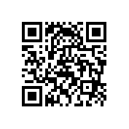
Course Director: Dr Jay Dasan; jaydasan@nhs.net

